Thanks for bidding on my INFORMATION. What follows is the result of much research on the part of the sellers, and much expense on my part-having bought these different "pieces" from the sellers.

As a seller could not restrict the sell of a cake recipe, for example, neither can a seller restrict the sale of information which can be, could be, or should be common knowledge. The information contained within this document falls within those guidelines. All information is either "common sense" (though how uncommon IS common sense these days?), or directs you to a very public source (a web site advertising on the WWW).

As with any compilation of information, I would suggest you try all these steps for yourself before "knowing" that they won't work. The most interesting of the bunch (How to Receive Consumer Electronics For Free) is so simple that you'll kick yourself for not thinking of it yourself. Just because it's simple, doesn't mean it won't work or doesn't work. If you really THINK about it-a small company has EVERYTHING to gain by doing business this way, and a large company has very little to lose by doing business this way!

As I intend to sell merchandise (as I have the past few months) as well as information, I would ask that you leave favorable feedback almost immediately upon receiving this promised information. It is as was described--information that I have bid on, and won, at a greater expense than I am asking of you. How it works for you, or how you make it work for you-all depends on your intelligence, your patience, and your ingenuity--none of which I have ANY control over! <g>

So-please, before you start using it-take this moment to leave feedback regarding the information, or the professional style, or the speedy delivery. I promise to do the same regarding the transaction afterwards.

Have fun with this!

Kevin
THIS PROGRAM IS NOT TO BE RESOLD; YOU DO NOT HAVE RESALE RIGHTS. (DO SO AT YOUR OWN RISK)

How You Can Receive Consumer Electronics and Other Products Completely Free!
Introduction

First off I would like to thank you for purchasing my program and in the near future you will most likely be thanking yourself for purchasing it also. I would suggest getting comfortable because once you get started you won’t want to stop. I know you are extremely anxious to know what exactly this bizarre sounding program is and how it works; now I am going to finally reveal this little known secret to you.

I’m sure you’ve received those worthless free product samples in the mail such as cat food, cereal, or maybe even shampoo which I receive occasionally for some odd reason. So why are these items for free? I know the items are worth nothing but the concept behind them is the same; the companies are willing to give your free samples to try to persuade you to buy their products.

Now I know what you are thinking, “Free cat food is one thing, but a free $2000 in-dash DVD player is impossible!” But guess what, it’s not! If you are a distributor or interested in selling a manufacturer’s specific product, they are usually very happy to send you one or more free sample units (even if it’s a $2000 in-dash DVD player) which are yours to keep! Usually all it takes is requesting a price quote and a sample unit, it’s that simple! They are yours to keep! Another great thing is once you have contacted a manufacturer regarding a product; it is not uncommon for them in the future to automatically mail you similar or related new models also. Remember an LCD monitor costing you $1200 may cost the manufacturer only $30 to produce, if not less. So you can see why most manufacturers don’t have a problem with mailing you a sample.

Getting Started
Please read everything over before you begin

STEP 1
As I mentioned the only things you need to get started are a mailing address such as your house or apartment, and an email address. I’m assuming you already have a house or apartment, but if for some reason you don’t you will need to get a post office box at a Mail Boxes Etc. or related service since some of your packages may require a signature upon delivery and they will sign on your behalf. Second you need an email address. You already have one since you received these files however I suggest setting up a second email account for business use. Your second email should be professional sounding; for example, something like “philsfan@sex.com” wouldn’t cut it. I would recommend the initial of your first name followed by your last name. If your name was John Smith, then “jsmith@email.com” would be great. A few good locations to get free email I have listed below. I wouldn’t suggest getting an email at Hotmail or Yahoo considering literally any username you can think of is taken and they are well-known for being used to spam.
www.email.com
www.postmaster.com
www.emailaccount.com
I also suggest opening up a free account with FedEx or DHL online using a debit or credit card. You will then be issued an account number. If you are unfamiliar with the way this service works, think of it as a credit card for shipping. You can include this account number with the emails you send. If the manufacturer requires you to pay for shipping, they can simply enter your account # on the international airwaybill for the package. The shipping costs are then billed to the credit or debit card on your account. You do not want to have these packages shipped overnight or two day airmail. As you can imagine a TV sent FedEx overnight from Malaysia to the US is not too frugal. Instead, check with the shipping courier your account is with (FedEx, DHL) by phone to speak with customer service and find out which international shipping method would be the absolute cheapest. DHL in most cases is the cheapest since they offer slower delivery than FedEx. Once you have researched and found which shipping method is cheapest (each courier has names, i.e. “FedEx International Economy Rate) mention in the email you would like the sample shipped using that method. Although paying for shipping is not necessary to receive free products, you should have much better success if you do. The cost of the sample usually isn’t what the manufacturer cares about; it is the cost of shipping.

STEP 2
Now that you have the two things necessary you can start. Instead of you searching and seeking out companies and their products directly, I am going to provide you with a website which will allow you to do it directly to begin with, which my company as well as hundreds of thousands of others uses. Eventually after you have done this for a while you will be able to search out other manufacturers directly to contact using search engines. However this website offers access to about 150,000 suppliers which are plenty to get started with.

www.globalsources.com

After you arrive at the website you will want to register for a membership, which is free. Click on the “Login/Register” and you will come to a page for current members to enter their login name and password, scroll below to where it says “register now.” Now that you will be conducting business relations you will need to have a name for your company. Once you have decided enter the name as well as the rest of your other contact information and submit. Then select the categories of items you are interested in if you would like to receive product alerts (optional).

Now you are ready to begin. On the main page of the Global Sources website, click on “product search” and from there you can either browse or search. Take an hour or so to relax and look around at products which interest you. Do not contact or request any samples yet.

STEP 3
Now that you have looked over the products it is time to start requesting your free samples. Since you are just starting, you should begin with products (from any category) that have a consumer retail value of $20 or less. Only after you have had some experience and received a few should you start requesting the more costly items such as televisions, DVD players, etc.

There are a couple ways you can contact the companies to receive your samples. Once you are on the page of a single specific product, you can click on the company’s name near the top (it should be in a blue font) which will take you to a page which will have their contact information including at least one or two email addresses. You can then email them from your email address.

Another way to email them is to click on “request sample” or “inquire now” on the product’s page; this will contact the companies through the Global Sources website instead of you emailing them directly.

When you email the companies, you should introduce yourself, mention you are interested in their product(s) and you would like them to send you more information regarding the product(s) as well as a sample unit. Be sure to include your mailing address. I have enclosed a picture of an actual sample correspondence between myself and a company (must censor text: company policy). What you write in your letter is up to you, it does not have to be long; a paragraph or so may do. The information contained in my letter is true; I do not advocate or support you writing any type of fictional information in your correspondences. Include your DHL or FedEx account number as well as the shipping method you would like if you opened an account.

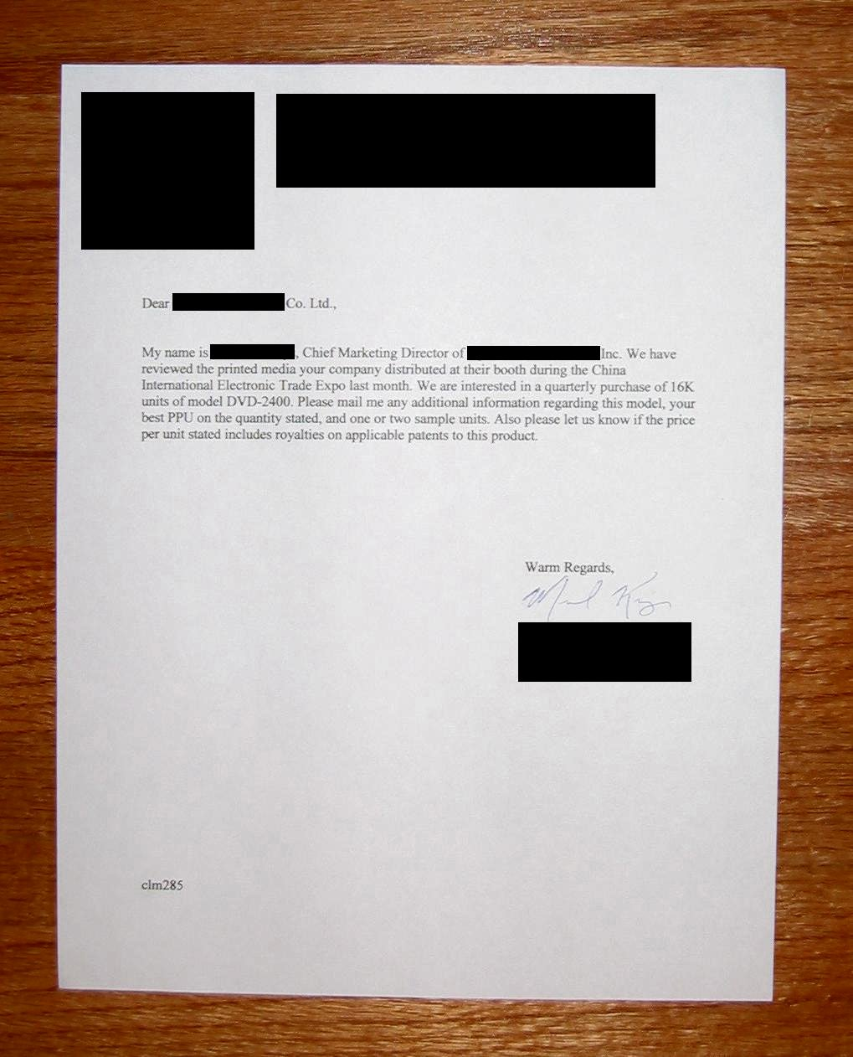

STEP 4
You may have to communicate by email with the companies a couple times back and fourth after your initial request. One thing I cannot stress enough is to be patient. In the United States, we do everything fast with a “gotta be done now, can’t wait” attitude and adhere to a strict schedule. Many other parts of the world including much of Asia are not like this. You may not receive a reply to your email for a few weeks. This does not mean they are ignoring you, that is just the way business is conducted there and they reply just as slowly to large corporations usually also.

When you do receive your free products, they will usually be shipped as a “commercial sample, no value” so you do not pay any tariffs on them. This is a very good thing; tariffs can be almost 40% of the product’s value! Below is a picture of an actual invoice.

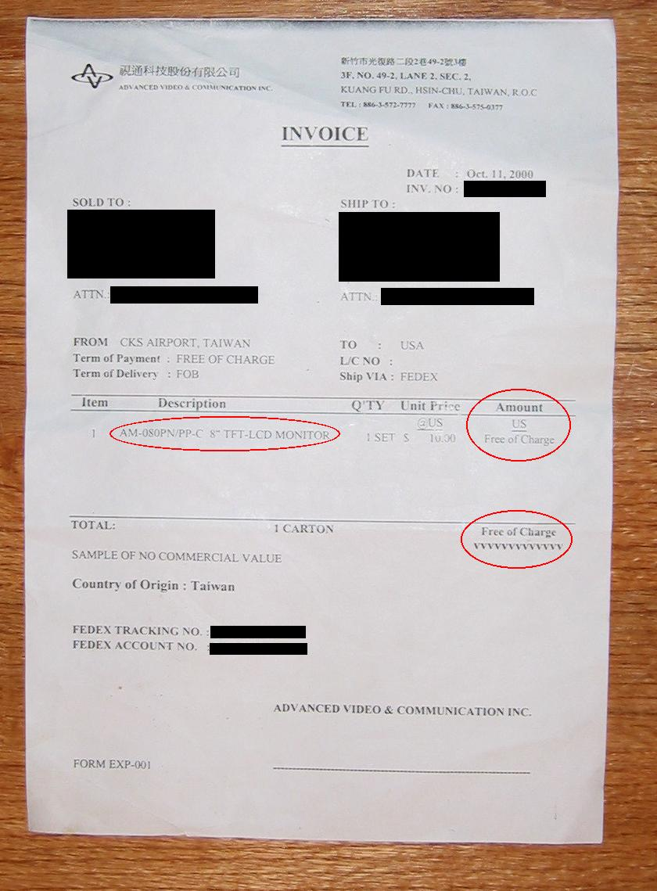

TIPS AND TRICKS:

(1) Remember there is no limit to how many different manufactures you can request samples from; the more you contact, the more free products you will receive.
(2) Start out small by requesting low valued items (products with a retail value of <$20) this allows you to gain the experience you need. It is very important you follow this step.
(3) Contact companies which do not have any of their products pictured. Click on the “view more suppliers” when you have came to the last page of the pictured products in a category. Email them and have them forward you their product brochures first.
(4) If you pay shipping costs you will have greater success.
(5) Be patient.
(6) After you are experienced you can begin contacting manufacturers not listed on Global Sources by locating them using search engines such as Yahoo.
(7) If there is a specific model you must have, and the company does not give out free samples, you can always purchase one or more at true wholesale cost.
(8) Stock up on free knick-knacks, these are ideal to begin with to get some experience. Some of my favorites include;
A. premium pens and stylish desktop clocks
B. health & exercise supplies (electronic ab belts, etc.)
C. golf accessories
D. novelties
E. things for the house, from extension cords to doorknobs
(9) Remember if you receive a product you don’t particularly like you can always sell them.
(10) Take your time and do not rush the process.

Victoria's Secret Wholesale Sources

VS Source #1 (www.wholesalestop.com/103)
This one is good if you don't have the capital to buy in bulk. It allows you to pre-order goods. You can send in a request for the amount you want, and when enough people have placed orders for the minumum purchase, they accept the payment and send out your goods. You get the low prices of large lots, without the cost. Defintely has a better selection too.

VS Source #2 (www.wholesalestop.com/154)
Once you build up a steady income using the first source, try this one out. You'll find some better deals here, but you have to order large quantities. This one occasionally has beauty products, but it looks like they sell out quickly...and again, you have to purchase bulk.

Tips for new sellers...

- Make sure you include pictures of all your merchandise in your auctions. Take a look at victoriassecret.com for professional quality pictures. Your auctions will be more likely to sell if you use these images rather than a picture taken by your digital camera of the item laying on your floor! Check the clearance and sale sections.
- Another great place to find pictures is on eBay. Check your competitor's auctions! Just right click on their picture and click properties. The URL is where the picture is located.
- You don't need to pay eBay to list your pictures. Use this code: <IMG SRC="http://www.yourserver.com/yourfile.gif>
- List "Buy It Now" prices just a few dollars above your minimum bid.
- Try other auction services! eBay isn't the end of the road...
- Include your business card with all items you send out! Get repeat customers!

Last but not least, is the wholesale source I have used most often since becoming a seller on EBAY. There may be other's out there, I don't doubt it. And there may be a better one springing up right now, even as I type this, but they have been very good and very dependable for me.

http://www.closeouts2000inc.com/viewlist.htm

Thanks very much for ordering the information. I know I grew frustrated after I received the "Information CD" for about the sixth time. Each "write up" in the auction was different and led me to believe I was getting something UNIQUE and DIFFERENT. I hope you don't feel that way about this information. I paid a total of $19.00 for the "WHOLESALE ELECTRONICS" information and $20.00 for the "VICTORIA SECRET'S" information-all within the past three weeks. You've paid substantially less--and at that-it's good information (I felt OK about paying what I did) at a bargain price! I hope you put it to good use!

Thanks again,

Kevin

